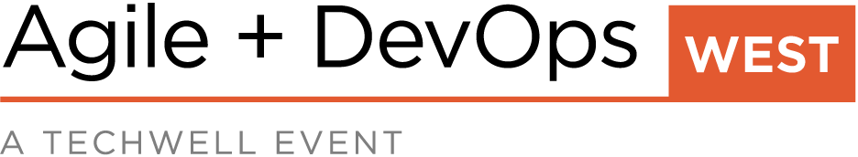
June 12–17, 2022
Attendee Name
Attendee Title and Department

Conference Summary Report
Provide a summary of the specific information you hoped to find at the event as well as specific benefits and knowledge gained that you hadn’t expected.

Recap any personal or company goals identified in your request to attend and how the knowledge and experience gained at the conference will help meet those goals.

Relevant, Realistic, and Refined Information to Share with the Team

Refer to your session notes, social media posts, and insight gained from the knowledge shared between attendees. Attach the list of sessions you attended to this report.

List the new information you’re bringing back, such as: relevant in-depth technical know-how; realistic new development and implementation approaches; tips to streamline your work; refined case studies of success to emulate; or promising new techniques and technologies.

Include any relevant presentation PDF files from the conference proceedings at https://members.techwell.com

People, Companies and Projects of Note

List a few key contacts you made during the conference, such as other attendees or conference speakers, and a brief description of their potential value to your organization.

List vendors and products or tools that interested you or might affect your company; case studies of special interest, or projects similar to what you are working on.

Action Items

List the top realistic action items to implement, such as: ideas for new approaches to problems; technologies to consider; training your employees or peers; case studies to share; or setting follow-up meetings with vendors or new business contacts.

